INTEGRATIVE TASK 1



DAVIDE FLAMINI CAZARAN - A00381665 - SYSTEMS ENGINEERING

NICOLÁS CUÉLLAR MOLINA - A00394970 - SYSTEMS ENGINEERING

ANDRES CABEZAS GUERRERO - A00394772 - SYSTEMS ENGINEER

ICESI UNIVERSITY

FACULTY OF ENGINEERING

COMPUTING AND DISCRETE STRUCTURES I

***PROBLEM SPECIFICATION TABLE***

| CLIENT | Airline |
| --- | --- |
| USER | Designated flight crew member |
| FUNCTIONAL REQUIREMENTS | * R1: Passengers Load into the System * R2: Passengers Arrival Registration * R3: Aircraft Boarding Order * R4: First Class Priority * R5: Aircraft Disembarking Order |
| CONTEXT OF THE PROBLEM | The issue at hand is the inefficiency in the airline's boarding and disembarking process, which is caused by the absence of a system that enables passengers to board and disembark efficiently. This results in delays and wasted time for both the flight crew and passengers. The goal is to improve this process in order to achieve a more comfortable and satisfying travel experience for the airline's customers. |
| NON-FUNCTIONAL REQUIREMENTS | * RN1: Efficiency passenger information retrieval * RN2: Intuitive user interface * RN3: The project must be uploaded to the Github platform and must have changes that allow the evolution of the project to be tracked. |

**ENGINEERING DESIGN PROCESS**

**Context Problem**

The issue at hand is the inefficiency in the airline's boarding and disembarking process, which is caused by the absence of a system that enables passengers to board and disembark efficiently. This results in delays and wasted time for both the flight crew and passengers. The goal is to improve this process in order to achieve a more comfortable and satisfying travel experience for the airline's customers.

**Solution Development**

Considering the context and nature of the problem at hand, we have opted to utilize the Engineering Method for the development of an effective and efficient solution. This systematic approach allows for a thorough analysis and understanding of the problematic situation, identification of necessary requirements, and establishment of clear and achievable objectives for the solution.

Based on the description of the Engineering Method from Paul Wright's book, "Introduction to Engineering," we have defined the following flowchart, which we will follow in the development of the solution.

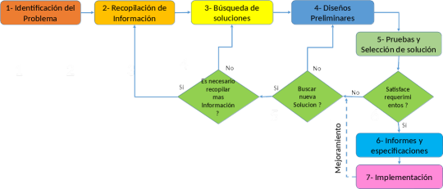

**Step 1: Problem Identification**

Symptoms and Needs:

* The airline needs to improve the order in the process of boarding and disembarking the aircraft.
* The corresponding passenger information for a flight needs to be loaded.
* Passengers need to be located and their arrival to the boarding area needs to be registered.
* It is necessary to show the order in which passengers should board the plane to the crew.
* Special rules must be established for the boarding of first class passengers, prioritizing other data such as accumulated miles, special attention required, seniority, or other relevant data.
* For disembarking, an exit order must be established for each row taking into account proximity to the aisle or order of arrival.

Causes:

* Lack of a system that automatically manages passengers and their information.
* Lack of a database that allows for passenger management.
* Lack of a model process for registering passenger arrival and departure.
* Inefficiency in the boarding process.
* Inefficiency in the disembarkation process.

Problem definition:

The problem consists of inefficiency in the boarding and disembarkation of passengers on an airline's planes. Currently, this process can be inefficient and can generate confusion, delays, and discomfort for both passengers and airline personnel. This is due to the lack of an automated system that allows for the management of passenger boarding and disembarkation. Therefore, the main objective is to develop an automated system that allows for the registration of passenger arrival to the boarding area and establishes the order of passenger boarding and disembarkation, displaying it to the responsible crew member. This is done while keeping in mind that the implementation of this system seeks to maintain a high standard of efficiency and reliability.